

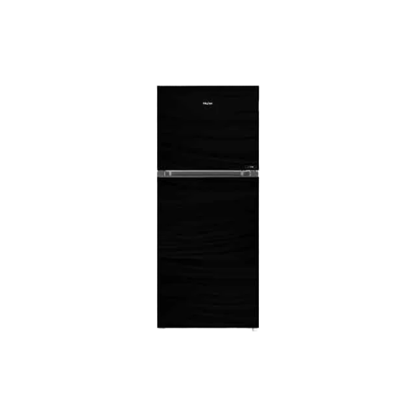

**Haier Refrigerator HRF-216 EPC/EPB/EPR**

• 8 CFT Size

• Free Standing Type

• Top Mount

• Direct Cool Cooling Technology

• Conventional Technology

• E-Star Series